|  |  |  |
| --- | --- | --- |
| *LSMA Beyond ~~-~~ Data Design* | *Red Text: Primary key* |  |
|  | *Blue Text: Foreign Key* |  |
|  |  |



Group 502~~-~~3

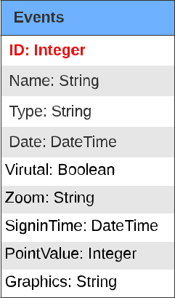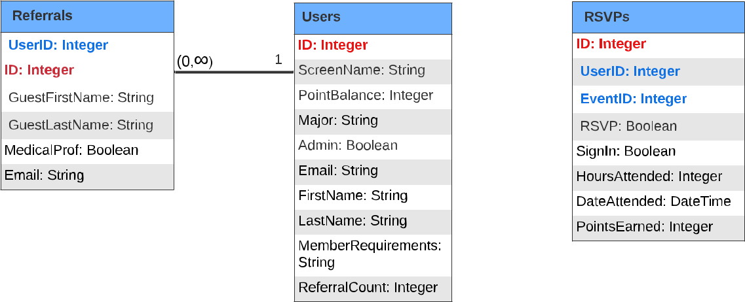

*Referrals*

*UserID:* *Integer*

*ID:* *Integer*

GuestFirstName: String

GuestLastName: String

MedicalProf: Boolean

Email: String

 (0,? ) 1

*Users*

*ID: Integer*

ScreenName: String

PointBalance: Integer

Major: String

Admin: Boolean

Email: String

FirstName: String

LastName: String

MemberRequirements:

String

ReferralCount: Integer

1. (0,? )



*RSVPs*

*ID: Integer*

*UserID: Integer*

*EventID: Integer*

RSVP: Boolean

SignIn: Boolean

HoursAttended: Integer

DateAttended: DateTime

PointsEarned: Integer

(0,? ) 1



*Events*

*ID: Integer*

Name: String



Type: String

Date: DateTime

Virutal: Boolean

Zoom: String

SigninTime: DateTime

PointValue: Integer

Graphics: String